**Notes for LAMP stack creation using GoDaddy – Instructions to recreate the color app**

***Hosting***

Go to: <https://www.godaddy.com/hosting/vps-hosting>

Remember, if you use a different provider you need CPANEL

Select second option:

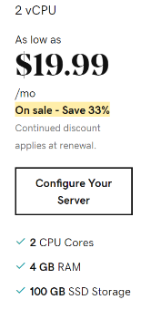

Select **Linux**, **1 Month**, and **cPanel/WHM**

Check Out: this should cost $44.99, cheaper than a textbook. This can be split amongst your group. It will take a few minutes for the virtual server to be ready.

Once the server has spun up, your GoDaddy dashboard (under servers) should have the following:



Click the Manage button

Configure your server (this only happens once)

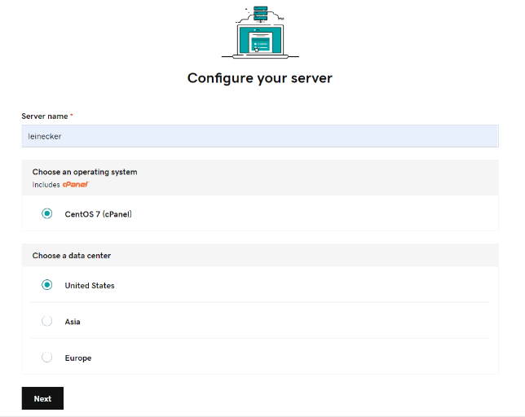

Set admin username and password

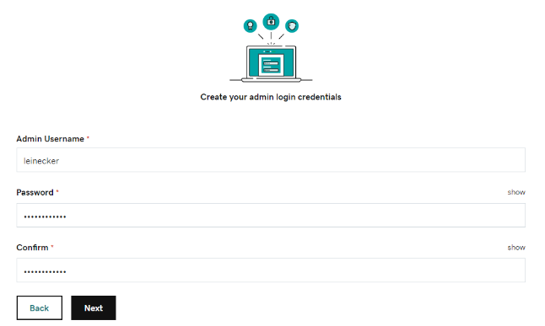

You will then see the server creation process



Please note, the server did not configure the first two times. On my third try it finished provisioning.

You will see that you don’t have any cPanel sites as below.

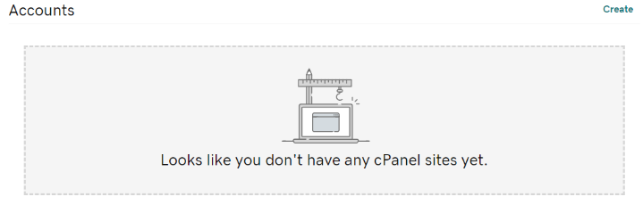

Click **Create**

Enter Information (I already had a domain that I used)

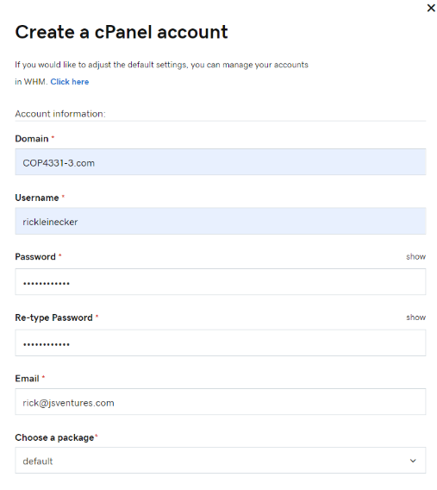

Once created you should see

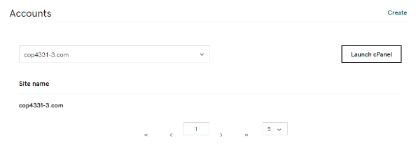

***Database***

Click the **Launch cPanel** button

Go to MySQL Database Wizard

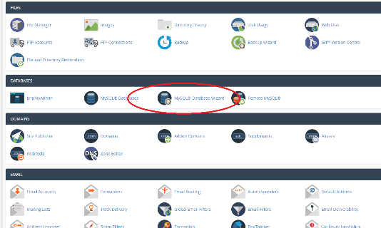

Create a new database (Note that there is a prefix based on the user name)

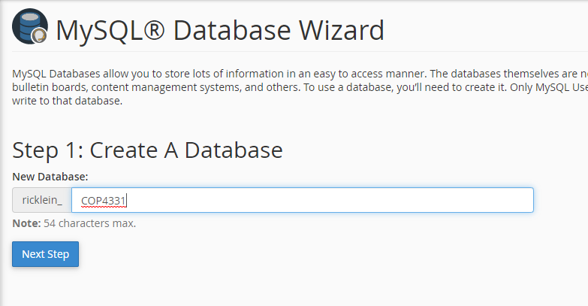

Create database user (Not that there is a prefix based on the user name)

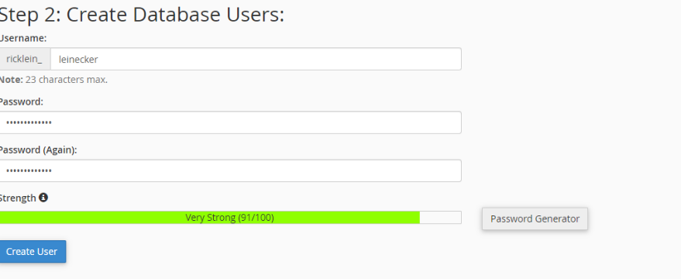

Give all privileges

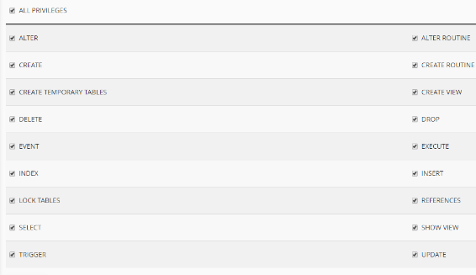

Finish and note this information

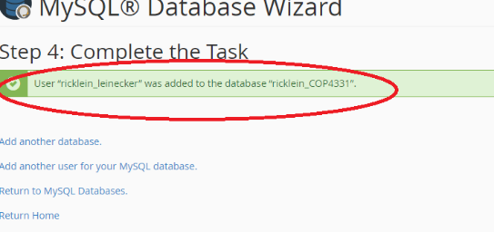

Click **Return Home** to go back to cPanel

Select **phpMyAdmin**

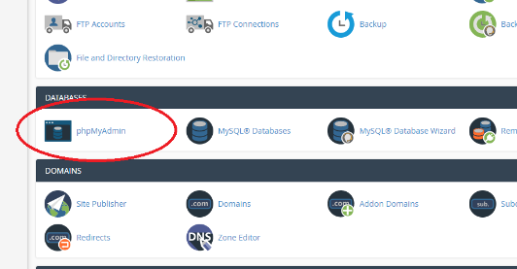

Select your new database

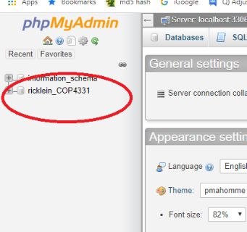

Create **Users** table

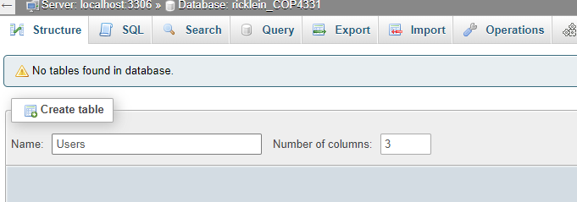

Add table fields (note that the ID is an autoincrement field)

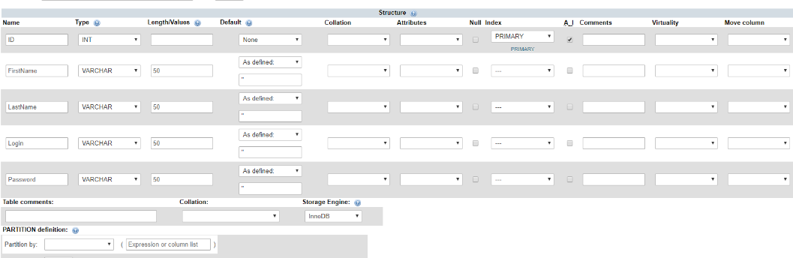

Go to SQL tab and insert some User records

insert into Users (FirstName,LastName,Login,Password) VALUES ('Rick','Leinecker','RickL','COP4331');

insert into Users (FirstName,LastName,Login,Password) VALUES ('Sam','Hill','SamH','Test');

Look at the table data (and note the user IDs)



Create the Colors table

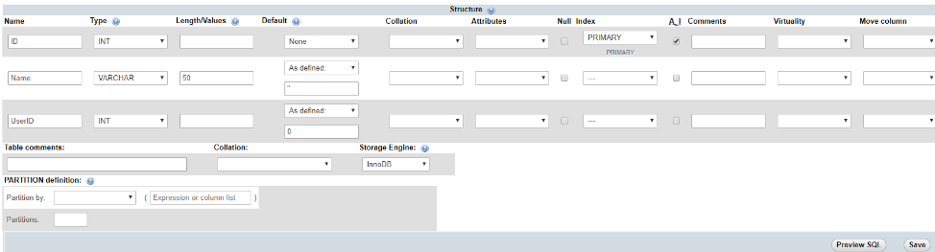

With the SQL tab, insert some color records

insert into Colors (Name,UserID) VALUES ('Blue',1);

insert into Colors (Name,UserID) VALUES ('White',1);

insert into Colors (Name,UserID) VALUES ('Black',1);

insert into Colors (Name,UserID) VALUES ('gray',1);

insert into Colors (Name,UserID) VALUES ('Magenta',1);

insert into Colors (Name,UserID) VALUES ('Yellow',1);

insert into Colors (Name,UserID) VALUES ('Cyan',1);

insert into Colors (Name,UserID) VALUES ('Salmon',1);

insert into Colors (Name,UserID) VALUES ('Chartreuse',1);

insert into Colors (Name,UserID) VALUES ('Lime',1);

insert into Colors (Name,UserID) VALUES ('Light Blue',1);

insert into Colors (Name,UserID) VALUES ('Light Gray',1);

insert into Colors (Name,UserID) VALUES ('Light Red',1);

insert into Colors (Name,UserID) VALUES ('Light Green',1);

insert into Colors (Name,UserID) VALUES ('Chiffon',1);

insert into Colors (Name,UserID) VALUES ('Fuscia',1);

insert into Colors (Name,UserID) VALUES ('Brown',1);

insert into Colors (Name,UserID) VALUES ('Beige',1);

insert into Colors (Name,UserID) VALUES ('Blue',2);

insert into Colors (Name,UserID) VALUES ('White',2);

insert into Colors (Name,UserID) VALUES ('Black',2);

insert into Colors (Name,UserID) VALUES ('gray',2);

insert into Colors (Name,UserID) VALUES ('Magenta',2);

insert into Colors (Name,UserID) VALUES ('Yellow',2);

insert into Colors (Name,UserID) VALUES ('Cyan',2);

insert into Colors (Name,UserID) VALUES ('Salmon',2);

insert into Colors (Name,UserID) VALUES ('Chartreuse',2);

insert into Colors (Name,UserID) VALUES ('Lime',2);

insert into Colors (Name,UserID) VALUES ('Light Blue',2);

insert into Colors (Name,UserID) VALUES ('Light Gray',2);

insert into Colors (Name,UserID) VALUES ('Light Red',2);

insert into Colors (Name,UserID) VALUES ('Light Green',2);

insert into Colors (Name,UserID) VALUES ('Chiffon',2);

insert into Colors (Name,UserID) VALUES ('Fuscia',2);

insert into Colors (Name,UserID) VALUES ('Brown',2);

insert into Colors (Name,UserID) VALUES ('Beige',2);

Check the Colors table

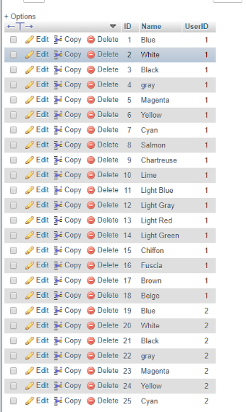

**Here: Talk about primary and foreign keys**

For this webapp the database is done.

***API***

There will be three API endpoints: AddColor, Login, and SearchColors. They each have a single .php file that is contained in the LAMPAPI directory.

Please note that there is a php statement that must be changed with your database username, password, and database name.

$conn = new mysqli("localhost", "username", "password", "database");

For our example that becomes

$conn = new mysqli("localhost", "ricklein_leinecker", "WeLoveCOP4331", "ricklein_COP4331");

There are three example .php files in the stacks\LAMP\LAMPAPI path of the file on the webcourse.

**Here: analysis of .php API endpoint files.**

From cPanel, select **File Manager**

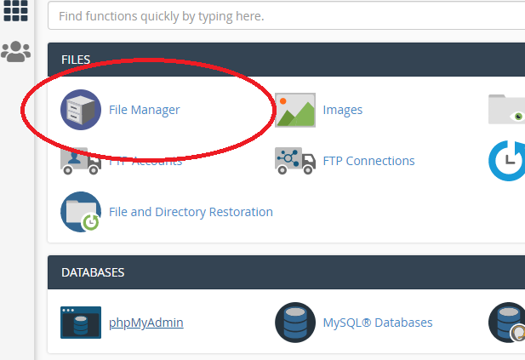

Drill down in the **public_html** directory

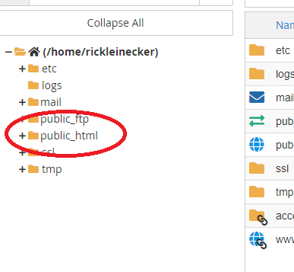

Create a **LAMPAPI** directory

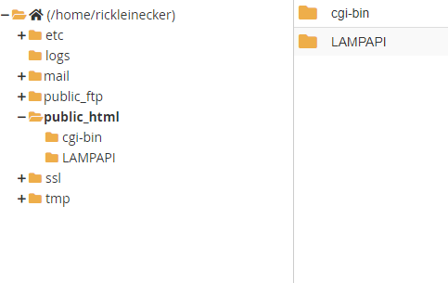

Upload the API endpoint files into the LAMPAPI directory.

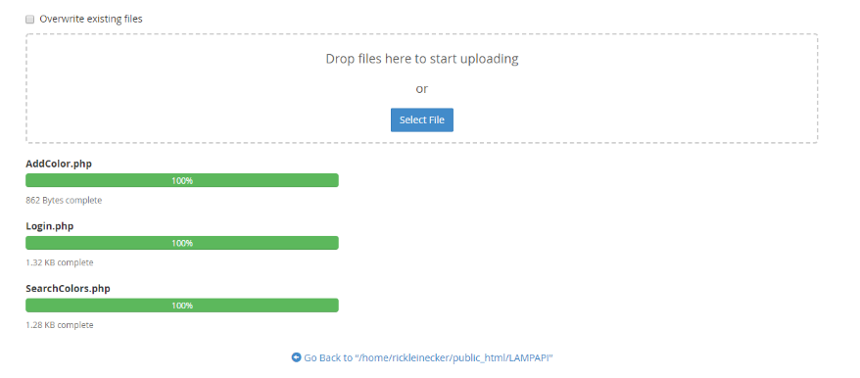

Now the API endpoints can be tested.

Use ARC or Postman or CURL or Swagger

http://cop4331-3.com/LAMPAPI/Login.php

login

password

http://cop4331-3.com/LAMPAPI/AddColor.php

userId

color

http://cop4331-3.com/LAMPAPI/SearchColors.php

userId

search

***Front End***

Upload css, images, js directories. Also upload color.html and index.html

**Here: Analysis of all source code**